Prepare for your Impact Discussion

Impact Discussions with your People Manager help you prioritize and pursue a meaningful, strategic career path. These questions will prepare you for your Impact Discussion by helping you reflect on your impact and focus on your future goals.


What is an Impact Discussion?
An Impact Discussion is a culmination of yearlong growth conversations between you and your People Manager. Together, you reflect on past experiences, celebrate success, and plan for the year to come. During this conversation, you’ll discuss your career growth, progress toward your goals, and ways to increase your impact in the future.

EYP Cornerstones

These dimensions define the ways in which we all make a difference for others every day and what impact looks like at Publicis Sapient. These cornerstones will be used to discuss progress, performance, and rewards. Learn more about the EYP Cornerstones on VOX.
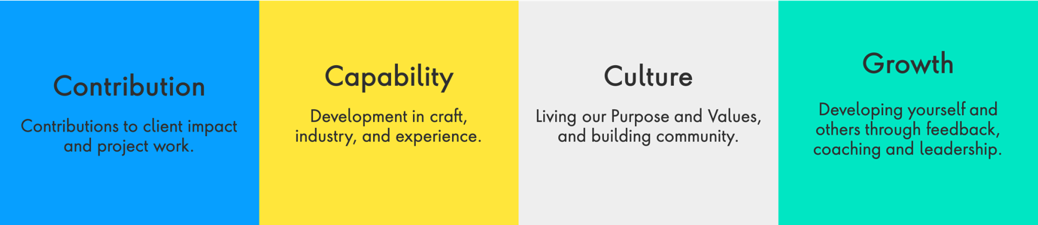

Step 1: Reflect on your impact

The questions below are the same questions your People Manager will use to guide your Impact Discussion. You’ll also find some helpful self-reflection exercises that will get you thinking about your impact from different perspectives. Combine any goals you may have set, feedback you may have gathered over the year, and your own self-reflections in your response.
Name: | Vishal Dwivedi
Title: | Senior Associate L2
People Manager: | Sunny Pahuja
Date of discussion: | 9-12-2020
Date of completion: | 9-12-2020

Question 1: Contribution
Share feedback from key stakeholders. What contributions have you made, and what impact have you had, in the company and with business partners, clients, and clients’ customers?
Self-reflection exercise:
Think about a project you worked on that had a great outcome.
- What unexpected skills did you contribute to this outcome?
- What unique experiences you’ve had in the past informed your contribution?
- How might the outcome have differed without your skills and experience?
Refer to Conversation Guides in the Vox Impact Discussion Toolkit for Capability Group specific reflection questions.

My feedback and self-reflection:
I developed a utility to generate the SQL scripts for MPUI application. Script was a manual work and it used to take usually a full day to generate even a mid-size script. Each developer have generate the script for MPUI. With the help of this utility the scripts can be generated within seconds. It helped us save us a lot of productive hours. My estimate is that we saved 4-5 day in the last release alone.
I was appreciated for this work in team meeting.

Question 2: Capability
Describe the capabilities and additional new skills you have developed to increase your impact.
Self-reflection exercise:
Review the Capability guides for your specific role, found in the Impact Discussion Toolkit.
- Which abilities described there come most easily to you, and which are a challenge?
- How have you continued to develop your strengths?
- How have you overcome or creatively compensated for your challenges?
Refer to Conversation Guides in the Vox Impact Discussion Toolkit for Capability Group specific reflection questions.

My feedback and self-reflection:
I had not worked much on SSIS packages prior to joining SDP team. I learned it side-by-side. Now I am a regular developer in SSIS.

Question 3: Culture
Give examples of how you are living our Core Values and contributing to our community and company culture.
Self-reflection exercise:
Review our Core Value Behaviors by career stage.
- Think of a recent choice you made that reflected one or more of our Core Values.
- What meaningful connections or relationships have you cultivated this year?
- Describe the communities you belong to within Publicis Sapient and how you’ve helped them thrive.
- How do you celebrate and recognize others? Describe a recent recognition you’ve given to a person or team.

My feedback and self-reflection:
I am learning AWS.
I have developed a good relation within team be it QA or developers or manager.
I ensure my availability for the team.

Question 4: Growth
Give examples of how you have developed yourself and others to enable growth.
Self-reflection exercise:
- In your role, what does it mean to help someone thrive in the brave pursuit of next?
- How have you helped others grow and learn? What can they do now that they couldn’t do before?
- Who are some people who you have learned from this year? What did you learn from them?

My feedback and self-reflection:
I work in SDP team in RBS. I had the working knowledge of MPUI before I joined this team. I increased my knowledge and shared it with new joiners. I also helped other developer in routine development work if they are stuck anywhere.

Step 2: Focus on your future
The exercise above helped you summarize your current impact. Now, consider the year ahead. Use the questions below to start thinking about growth areas and opportunities that are important to you.

Question 1: What type of work, activities, or projects would you like to do more often?
Self-reflection exercise
Think of a time you were doing work that made you feel proud and energized. What opportunities might exist for you to do more work like this?

Type of work | Opportunities to pursue
Want to work on Cloud | Client may be moving the SDP application to cloud. I want to be part of that project.
<write your response here> | <write your response here>
<write your response here> | <write your response here>

Question 2: What new skills or capabilities would you like to learn?
Self-reflection exercise
Imagine yourself one year in the future, doing work that makes you feel fulfilled, energized, and proud. What would you need to learn to do this work to the very best of your ability?

Learning goal | Opportunities to pursue
AWS certification | To be part of the team that work on taking the SDP application to cloud.
<write your response here> | <write your response here>
<write your response here> | <write your response here>

What’s next for you? What do you want to prioritize in the year ahead? Although your goals will change over time, it’s still important to consider your goals today.
1-3 years
New areas of the business
Potential future roles
Benefits for both you and the business
Want to earn AWS cloud certification.

Step 3: Have a meaningful discussion with your People Manager
Work with your People Manager to schedule your annual Impact Discussion in November. Use this guide to help you have a quality conversation. Optionally, you may also share this document and your responses with your People Manager as input to the Impact Discussion they will document in the EYP Tool.

